TOPCODER - Hyperion SME consultancy CHALLENGE SUBMISSION

1. Introduction

Hyperion Planning has been chosen as the tool to replace the current AMP Financial Planning systems and improve processes. The solution will be supported by operational data store (ODS) to ensure data is stored centrally and will provide transformed data required by upstream or downstream system

1.1 Purpose

The purpose of this document is to help or provide consultancy to the Development team for Hyperion 11.2.6 upgrade project

1.2 Scope

The scope of this challenge is to build/help Non-Prod and Prod setup in new environment.

2. Architectural Representation

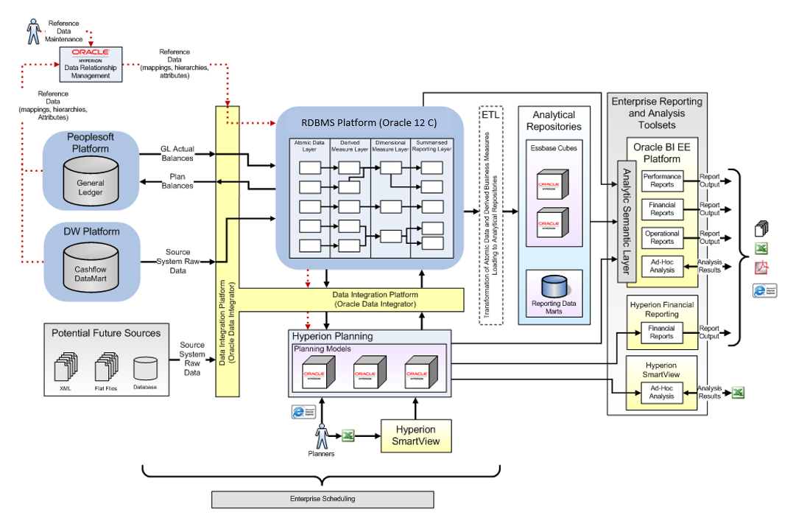

3. Size and Performance

The sizing and performance requirement is

* The system shall support up to 400 simultaneous Hyperion user’s
* The system shall provide access using AD groups.
* The system must be able to complete 80% of all transactions within short time as per SLA.

4. Quality

The quality requirement is

* There should not be any performance degradation with new upgraded version as compared to existing version.
* The data accuracy and consistency should be larger than 99.9999%